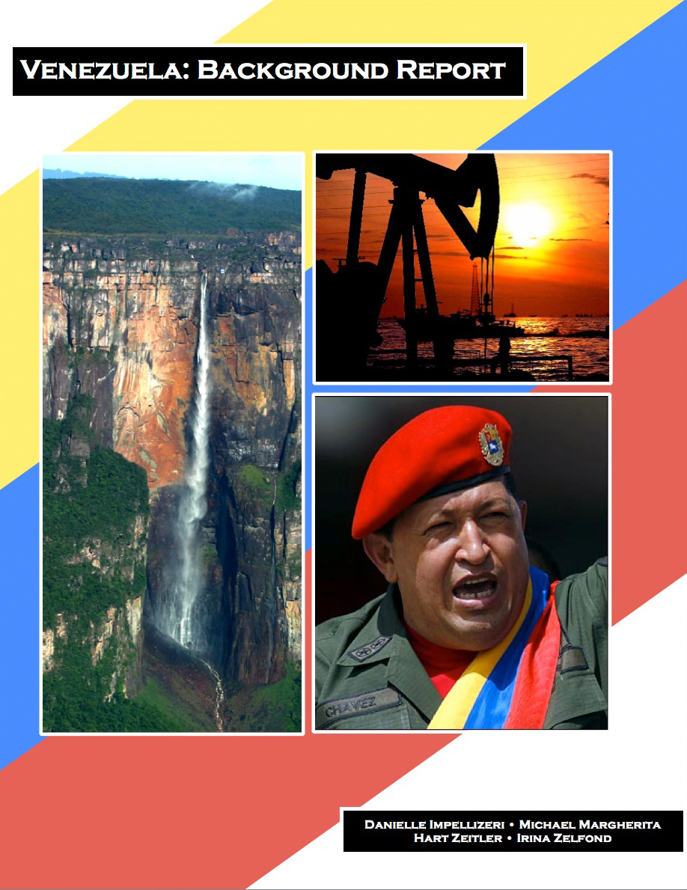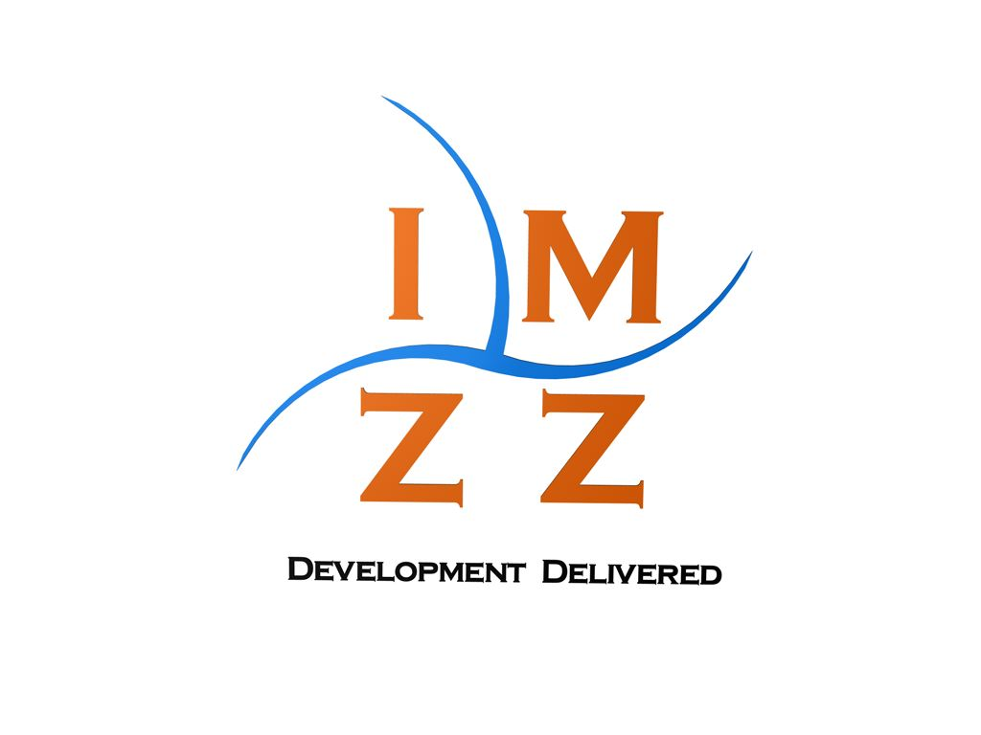

Table of Contents

Introduction 4

Definition of Development 5

A Brief Overview of Venezuelan Polity 6

Venezuela & Oil 8

Recent Trends 10

Economic Overview 10

Education 13

Literacy Rates 13

Primary School Enrollment 16

Secondary School Enrollment 17

Progression and Completion of Education 20

Resource Devotion to Education 20

Healthcare 22

Life Expectancy 23

Infant Mortality Rates 24

Access to Safe Drinking Water 25

Access to Improved Sanitation 26

Venezuela’s Recent Performance: Theoretical Perspectives 27

Dependency Theory 28

Modernization Theory 28

Planning School 29

Radical School 30

Future Absent Policy Change 30

Development Potential 32

One Gap 32

The Two Gap 38

Currency 38

Composition of Exports and Imports 40

Trade Balance 41

Debt 43

Three Gap 45

Secondary Education 47

Constraints 49

Policy Proposals 54

Investment in Secondary Education 54

Control of Corruption 54

Investment In Oil 55

# Introduction

Countries today are faced with the all-encompassing challenge of development. Differences among histories, cultures, and political environments cause countries to choose and follow various paths to attain a higher level of development. This paper will examine and analyze Venezuela’s experience with development thus far, as well as make recommendations for the future. Our goal is to identify key issues hindering development in Venezuela and to arrive at solutions. Ultimately, we will be presenting our findings to the government of Venezuela and we hope that they value and accept our proposals.

We begin this paper by defining development and identifying where we place Venezuela according to this definition. Following, a brief overview of the political environment of Venezuela and an analysis of the oil sector is required in order to better comprehend why Venezuela is where it is today and what the future holds for the nation. We will continue by tracing the recent trends of development, mainly in the economy, education, and healthcare arenas. We will also consider a few different theories of development and judge how well they apply to Venezuela. At this point, we will hypothesize what the future of Venezuela will be if no changes in policy are undertaken.

We will then examine financial aspects of the economy, specifically the one, two, and three gaps, which play a vital role in assessing development potential. We will identify the key areas in which certain improvements would yield the greatest impact on the overall performance of Venezuela. We also will identify possible constraints that could prevent the adoption or undermine the success of a given policy. With all of this considered, we will conclude with a rough policy proposal that we determine will have the greatest positive effect on Venezuela.

# Definition of Development

Assessing the level of development of a nation requires both a definition of development as well as related metrics. In a word, development is opportunity.  Opportunity, however, is not a universal concept for every nation; the core meaning of opportunity exists on a spectrum.  To any given country we can assign one of three broad levels of development.  It should be noted that this is not a rigid structure; nations gradually progress through the different metrics for opportunity.  It is not necessary to completely fulfill the requirements of one level before progressing to the next; it is a fluid process.  Each of these levels has different requisites for enhancing opportunity. The first level, that of the least developed country, is to ensure the basic needs of the population are met.  It is the ability to move from a subsistence lifestyle to one that is progressive and sustainable: an individual can look beyond the provision of the basic necessities of life towards a more expansive future.  The second level, that of the moderately developed country, focuses on improving the social and political landscape as well as establishing infrastructure. It is social mobility, the ability to participate in an effective government free from rampant corruption, and the presence of reliable infrastructure.  The third level, that of the developed country, involves ensuring the previous requisites of opportunity are available to everyone.  It is not enough that a simple majority has its basic needs met and has social and political freedoms.  This level requires efforts to bring development to every last citizen.  These development processes must not be temporary or fleeting, but rather dynamic, self-sustaining, and continuous. Development facilitates the chance to live a eudaimon life.

Opportunity, however, is an abstract concept, and thus difficult to quantify. Of the four proposed indicators for encapsulating development (economic growth, economic growth coupled with social change, human development, and liberation) human development best reflects our definition. As such, the best way to assess the first level of development is with education and healthcare data. A population that is both educated and healthy is fundamental for development. Venezuela has progressed beyond the first level, and currently resides within the second. Indicators for the second level include various dimensions of governance such as government effectiveness, rule of law, and voice and accountability.

# A Brief Overview of Venezuelan Polity

Much of Venezuela’s 19th century history was marked by periods of political instability, dictatorial rule, and revolutionary turbulence. The first half of the 20th century was heralded by authoritarianism, including dictatorships from 1908-1935 and 1950-1958. Since the overthrow of General Marcos Perez Jimenez in 1958, and the withdrawal of the military from direct involvement in national politics, Venezuela has enjoyed an unbroken tradition of civilian democratic rule.

The Constitution of 1999 designates two main branches of the federal government: the executive and legislative branches. The president of Venezuela, who acts as both chief of state and head of government, is elected by popular vote for a six-year term, and is eligible for unlimited reelection. The president also appoints the vice president, determines the size and composition of the cabinet, and makes appointments to the cabinet in consultation with the National Assembly. The National Assembly is unicameral, consisting solely of the Chamber of Deputies. Deputies are elected by popular vote for five-year terms and are eligible for unlimited reelection.

The Constitution of 1999 designates three additional branches of the federal government: the judicial, citizens, and electoral branches. The judicial branch of the government is composed of the Supreme Tribunal of Justice, in which the National Assembly elects thirty-two magistrates for a single twelve-year term. The judicial branch also consists of lower courts, including district courts, municipal courts, and courts of first instance. The citizens branch of the government consists of three components: the attorney general, the “defender of the people” or ombudsman, and the comptroller general. The holders of these offices are selected by the National Assembly to serve seven-year terms. The electoral branch of the government, known as the National Electoral Council, is responsible for organizing elections at all levels. Its five members are selected by the National Assembly to serve five-year terms.

The current president of Venezuela, President Hugo Chavez Frias, was elected in 1998 under a campaign for broad reform, constitutional amendment, and a crackdown on corruption. This campaign was revitalized in 2007 under the moniker of “21st Century Socialism,” and seeks to alleviate social problems while simultaneously attacking both capitalist globalization and existing democratic institutions. Over the course of his tenure, President Chavez has largely focused the attention of his administration on the implementation of social programs designed to benefit Venezuelan society as a whole. Indeed, much of this spending has been directed toward poverty alleviation.

# Venezuela & Oil

Any discussion of Venezuela requires a thorough analysis of the nation’s oil sector. Oil is the key driver of the Venezuelan economy and society; oil profits *Figure 1*: *Venezuela’s GDP versus Oil Price* constitute 80% of Venezuela’s export revenue and half of government revenue[1]. As Figure 1 illustrates, there is a strong correlation between Venezuela’s GDP and oil prices. An oil-based economy is something that Venezuela can sustain far into the future. Throughout Venezuela’s oil producing history (starting in 1917) the nation has produced a cumulative total of 60 billion barrels of oil[2]. As of 2008, Venezuela has over 172 billion barrels of proven reserves. In 2007, Venezuela only had 100 billion barrels of proven reserves, which leads one to believe more oil may be found in the future. Conservatively estimating that Venezuela will not generate any additional proven reserves, and assuming the doubling of production that took place between 1988 and 2008 is representative of future trends[3], Venezuela will have oil until 2062 (52 years). If one assumes the current production rate of 300,000 barrels per day will continue, their oil reserves will last for the next 155 years. Thus, Venezuela does not need to worry about a loss of oil revenue due to lack of supply in the short term. Other aspects of the oil sector, however, are of concern in the short term.

Chavez’s tenure as president has fundamentally changed the oil industry in Venezuela. In 2006, President Chavez further nationalized the industry (the Venezuelan government already controls 100% of PDVSA, the nation’s petroleum company) with a focus on oil fields, and the government’s stake in the sector increased from 40% to 60%[4]. President Chavez has also steered oil money away from the oil industry in attempts to both diversify the economy and promote social welfare, an act that has far-reaching consequences. According to Bernardo Alvarez Herrera, Venezuela’s ambassador to the United States, Venezuela’s non-oil sectors are actually growing faster than Venezuela’s oil sector, due in part to transferred funds from the oil sector[5]. President Chavez also has plans to diversify the national oil firm, PDVSA. In 2007 President Chavez created subsidiaries dedicated to agriculture, shipbuilding, and construction, among others, within the company. This diversification could be key to Venezuela’s future, as its current intertwinement with oil prices does not provide stable economic conditions. According to the Center for Economic and Policy Research, President Chavez’s spending on social welfare has, among other metrics, decreased poverty by 50%, increased access to education and healthcare services, and pushed unemployment below 10%[6]. The commitment to economic diversification and the social benefits that have arisen from oil revenue are positives for Venezuela. However, diverting such significant sums of money away from the oil sector will have negative ramifications in the future. While Venezuela’s total reserves are vast, tapping those reserves requires consistent investment in infrastructure, investment that has been lacking under President Chavez.[7] Experts maintain that PDVSA will need to invest, at minimum, $3 billion annually to maintain its current levels of production. The investment will need to be higher to access the less conventional reserves that make up a large portion of Venezuela’s proven reserves, especially in the Orinoco Belt region.[8] Managed correctly, Venezuela’s oil reserves could provide the resources required for development. However, a lack of attention to infrastructure and upkeep could drive Venezuela backwards as oil revenues, used to temporarily provide social welfare and diversification, shrink.

# Recent Trends

## Economic Overview

While our definition of development does not fully embrace economic indicators as key aspects of development, they can still act as a foundation and reference point for other important metrics. The most basic of economic metrics are GDP, GDP per capita, and the change in these numbers over time. As Figure 2shows, Venezuela’s GDP (Real, 2005 US dollars) has grown at a typical rate for the region, but lags behind the comparable nations. Figure 1[9] illustrates GDP as relative growth compared to GDP in 1999. Thus, a point approaching 2 on the graph indicates a doubling of GDP from 1999, and a point approaching 1.5 indicates a 50% increase in GDP from 1999.

*Figure 2*: *Real GDP, 2005 US Dollars Relative Growth*

Interestingly, Venezuela’s path to typical growth has been erratic. During the first part of the decade, Venezuela went through a significant recession, in which their GDP fell to 86% of the 1999 level in 2003. This recession had two main causes – the 2002 attempted coup and the resulting turmoil in Venezuela, and a month-long strike of oil workers.[10] This strike had a significant effect on Venezuela, as the oil industry accounts for about one third of the Venezuelan economy.[11] High oil prices in the following years, however, enabled Venezuela to recover from this recession and achieve long-term growth in line with the rest of South America. Specifically, Venezuela’s real GDP in 2005 US dollars grew from 122 billion in 1999 to 173 billion in 2008. GDP per capita (PPP, 2010 US dollars) grew from about 8,010 in 1999 to about 12,800 in 2008.

*Figure 3*: *Income Distribution by Quintile*

This increase in economic wealth was accompanied by a slight increase in equality within Venezuela. While inequality remains an issue in Venezuela, inequality has declined by two measures, the GINI coefficient and wealth distribution by quintile (Figure 3[12]). The GINI coefficient is a numeral representation of income distribution equality. As the GINI coefficient approaches 100, incomes become more unequally distributed within a nation. Venezuela’s GINI of 48 in 2003 and 2005 are relatively high values (this places Venezuela in the bottom fourth of nations[13]), but a drop to 43 in 2006 shows progress.

Also, as Figure 3 shows, income distribution among the quintiles has become slightly more equal. Between 2003 and 2006, the income of the wealthiest 20% dropped by 3% (from 52% to 49%), and the income of the poorest 20% increased by 2% (from 3% to 5%). The slight decline in income inequality in Venezuela can be explained by a shift out of poverty for many people during the decade, as is illustrated by Table 1[14]. Largely driven by oil revenue, poverty declined dramatically in Venezuela from 2003 to 2006.

*Table 1: Poverty Headcount Percent of Population (PPP)*

|  |  |  |  |
| --- | --- | --- | --- |
|  | **2003** | **2005** | **2006** |
| **$1.25/Day** | 18 | 10 | 4 |
| **$2.00/Day** | 32 | 20 | 10 |

## Education

Education is a prerequisite of opportunity. An uneducated or undereducated population cannot sustain development. The most effective measures of education within a population include literacy rates, primary and secondary school enrollment, and the overall ubiquity of, and access to, educational opportunities. The rates of progression and completion of education, as well as the amount of public expenditures directed toward education, are similarly significant in determining the state of a country’s educational system.

### Literacy Rates

Literacy rates can be an extremely useful indicator of human development; they illustrate how deeply education has penetrated society. If, for example, literacy rates are low across various dimensions (age, gender, class, race, etc.), we can assume that there is limited opportunity and most likely high inequality. The existence of high literacy rates can serve to indicate a certain degree of development in education and begin to allow us to see the educational system overall. While high literacy rates do not necessarily signify that an educational system is effective, they are an essential starting point from which an educational system can progress.

Education at its most basic level has improved in Venezuela. As Figure 4[15] illustrates, literacy rates in Venezuela have increased across both the age group and gender dimensions over the period 1990 to 2007. The most impressive increase of 5.9% occurred in the adult age group among females; the least impressive increase of 2.4% occurred in the youth age group among females. The overall average rate of improvement in literacy across both the age group and gender dimensions over this period is 4.15%: that percentage translates into an increase of roughly 0.23% per year.

Education at its most basic level has been relatively successful in Venezuela in comparison to similar countries, as illustrated in Figure 5.[16] Venezuela’s literacy rates are slightly higher than both the regional and comparable country averages.

*Figure 4: Percentage of Literate Adults and Youth in Venezuela in 1990 and 2007*

*Figure 5: Percentage of Literate Adults and Youth in Venezuela, the region, and comparable nations in 2007*

### Primary School Enrollment

Primary school enrollment rates are an extremely important indicator of development in that they represent a population’s access to the most basic foundations of comprehension and understanding.

Over the period 1999 to 2007, Venezuela experienced an initial surge in NER[17], followed by a period of relative stagnation. As shown in Table 2*[18]*, primary school enrollment rates underwent significant change in Venezuela over the period 1999 to 2002, with each group (total, male, and female) experiencing a 7% increase in primary school enrollment. However, primary school enrollment rates underwent little to no change over the period 2002 to 2007, with the male group experiencing no change at all, and both the total and female groups experiencing a 1% decrease.

Venezuela’s performance in terms of primary school enrollment is relatively on par with that of similar countries. Figure 6[19] shows that primary school enrollment rates in Venezuela are high at 92%, though this rate is two percentage points less than the regional average of 94%. In terms of comparable nations, Venezuela, with a total primary school enrollment rate of 92%, is again two percentage points less than the average of 94%.

*Table 2: Primary School Enrollment Rates in Venezuela in 1999, 2002, and 2007*

|  |  |  |  |  |
| --- | --- | --- | --- | --- |
| **Primary School Enrollment Rates** |  | **1999** | **2002** | **2007** |
| **GER (%)** | Total | 100 | 106 | 106 |
|  | Male | 101 | 108 | 107 |
|  | Female | 99 | 105 | 105 |
| **NER (%)** | Total | 86 | 93 | 92 |
|  | Male | 85 | 92 | 92 |
|  | Female | 86 | 93 | 92 |

*Figure 6: Primary School Enrollment Rates in Venezuela, the region, and comparable nations in 2007*

### Secondary School Enrollment

Secondary school enrollment rates are another extremely important indicator of development in that they demonstrate a population’s access to an education that is focused on future opportunities, such as employment.

As shown by Figure 7*[20]* below, secondary school enrollment rates in Venezuela have shown steady improvement over the period 1999 to 2007. In almost every instance, Venezuela experienced an increase of ten or more percentage points. For example, from 1999 to 2002, total secondary school enrollment increased from 47% to 57%, and from 2002 to 2007, increased from 57% to 68%. However, it is extremely important to note that, while these increases have occurred and are to be commended, total secondary school enrollment remains fairly low at 68% as compared to total primary school enrollment at 92%.

Figure 8*[21]* illustrates that the secondary school enrollment rate is slightly less than the regional average of 71%. At this stage, it is unclear whether lower than regional average enrollment rates are a consequence of financial cost, opportunity cost, social stigma, or lack of supply of education.

*Figure 7: Secondary School Enrollment Rates in Venezuela in 1999, 2002, and 2007*

*Figure 8: Secondary School Enrollment Rates in Venezuela, the region, and comparable nations in 2007*

### Progression and Completion of Education

Statistics related to the progression and completion of education can serve to demonstrate the effectiveness of a country’s educational system. Table 3[22] provides information on the progression and completion of education in Venezuela in 2000 and 2008, unless otherwise noted. In Table 3, school life expectancy is measured by the International Standard Classification of Education.[23] Educational progression and completion in Venezuela is demonstrably strong, with 98% of students enrolling in the last grade of primary school in 2007, and 95% of students making a successful transition from primary school to secondary school in 2007; this transition rate, however, has decreased from a transition rate of 99% in 2000. At the same time, the percentage of students who repeat any grade in either primary or secondary school has decreased significantly, and the expected time period in which a student will remain enrolled has increased from 10.5 years in 2000 to 14.2 years in 2008.

*Table 3: Progression and Completion of Education in Venezuela in 2000 and 2008*

|  |  |  |
| --- | --- | --- |
| **Progression and Completion of Education** | **2000** | **2008** |
| Gross Intake Rate to Last Grade of Primary (%) | - | 98 (2007) |
| Percentage of Repeaters, Primary (%) | 7 | 3 |
| Percentage of Repeaters, Secondary (%) | 10 | 3 |
| Primary-to-Secondary Transition Rate (%) | 99 | 95 (2007) |
| School Life Expectancy ISCED 1-6 (Years) | 10.5 | 14.2 |

### Resource Devotion to Education

Overall resource devotion to education can be extremely helpful in understanding the degree to which a government is involved in the educational process. If, for example, a government spends a relatively high percentage of its GDP on education, and if those expenditures are reflected in high literacy and/or enrollment rates, it may be assumed that government spending on education is being used efficiently and appropriately. Table 4[24] below provides information on the resources devoted to education in Venezuela in 2007, including public expenditure on education and the distribution of public expenditure per level. It is important to note that public expenditure on secondary education is approximately half of public expenditure on primary education, 17% and 32% respectively. Furthermore, tertiary expenditure, at 43%, is significantly higher than both primary and secondary expenditure. It is entirely possible that this concentration of spending has influenced enrollment rates in Venezuela, and this disparity in spending may be an area in which Venezuela could seek to improve, i.e. redistributing funds more efficiently among the various levels of education.

*Table 4: Resource Devotion to Education in Venezuela in 2007*

|  |  |
| --- | --- |
| **Resource Devotion to Education** | **2007** |
| Public Expenditure on Education as % of GDP | 3.7 |
| **Distribution of Public Expenditure per Level (%)** | |
| Pre-Primary | 7 |
| Primary | 32 |
| Secondary | 17 |
| Tertiary | 43 |
| Unknown | 1 |

In order to comprehend the overall significance of Venezuela’s public expenditure on education as a percentage of GDP, we examine that same percentage in various countries throughout the Latin American and Caribbean region. As shown in Table 5*[25]* below, Venezuela devotes only 3.7% of its GDP to public expenditure on education, while Cuba devotes 13.3%, though Cuba is itself an exception to the general tendencies of the region. On average, and excluding Cuba due to its status as an outlier, countries in Latin America and the Caribbean devote 4.3% of GDP to public expenditure on education, slightly higher than Venezuela’s 3.7%.

*Table 5: Public Expenditure on Education as % of GDP in the Region in 2007*

|  |  |
| --- | --- |
| **Country** | **Public Expenditure on Education as % of GDP in 2007** |
| Cuba | 13.3 |
| St. Vincent and the Grenadines | 7.0 |
| Barbados | 6.9 |
| Guyana | 6.1 |
| Jamaica | 5.5 |
| Belize | 5.1 |
| Aruba | 4.8 |
| Costa Rica | 4.7 |
| Colombia | 4.1 |
| Dominica | 4.1 |
| Venezuela | 3.7 |
| Chile | 3.4 |
| British Virgin Islands | 3.1 |
| El Salvador | 3.0 |
| Guatemala | 3.0 |
| Peru | 2.5 |
| Dominican Republic | 2.2 |

## Healthcare

The health levels of a population are instrumental in identifying development of a country. The progress a country makes in improving its health statistics begins to illustrate the commitment level of the state in investing in human development. Generally, Venezuela has been successfully improving its basic health statistics such as life expectancy and infant mortality rates. Venezuela tends to perform better than the South American region in terms of these health statistics as well. While room for improvement remains, additional attention to healthcare is not an urgent need of the country and attention to other areas will most likely prove to have a larger impact on overall development.

### Life Expectancy

Life expectancy proves to be very useful when looking at overall levels of health in any given country. Looking at the progress a country has made in terms of life expectancy over some period of time provides insight into the progress of overall development in that country. In the case of Venezuela, we observe a steady, upward movement in life expectancy, which means that the average Venezuelan is living longer than Venezuelans before him. Table 6 shows data for Venezuela’s life expectancy for the whole population, the male population, and the female population for three years: 1990, 2000, and 2007. Over this period of 17 years, Venezuela’s total population has seen a 4.17% increase in average life expectancy. Venezuela has a relatively high life expectancy to begin with and continues to show signs of improvement. While the region has seen a higher increase in life expectancy of 7.02% than Venezuela, this is due to the fact that more than half of South American countries began in 1990 at a lower life expectancy than Venezuela, and it is easier to increase when starting at a lower value. Venezuela has been steadily improving upon life expectancy and is currently doing well as compared to the region, as the 2007 regional average was 72.4 years.[26]

*Table 6: Life Expectancy*[27]

|  |  |  |  |
| --- | --- | --- | --- |
|  | **Life Expectancy (1990)** | **Life Expectancy (2000)** | **Life Expectancy (2007)** |
| Total | 72 | 74 | 75 |
| Male | 70 | 71 | 72 |
| Female | 74 | 77 | 78 |

### Infant Mortality Rates

As we examine infant mortality across time for Venezuela, we observe a consistent decrease in the rate for the total, male, and female populations. A falling infant mortality rate allows us to infer that at least some development is occurring in the medical care field. Table 7 shows Venezuela’s infant mortality rates for the total, male, and female populations for 1990, 2000, and 2007. Venezuela has experienced a 37% drop in infant mortality rates in its overall population, placing it at a rate of 17 as of 2007, lower than the regional average of 22. It is to be expected that as the infant mortality gets lower, it becomes more difficult to lower it further. This phenomenon tends to occur because initial attempts at reducing infant mortality rates are relatively cheap and have a large impact, but as progress is made it becomes more expensive to further reduce rates and later attempts do not have as large an impact. Therefore, there is a significant difference in the percent change in the infant mortality rate from 1990 to 2000 (25%) and from 2000 to 2007 (15%).

*Table 7: Infant Mortality*[28]

|  |  |  |  |
| --- | --- | --- | --- |
|  | **Infant Mortality (1990)** | **Infant Mortality(2000)** | **Infant Mortality (2007)** |
| Total | 27 | 20 | 17 |
| Male | 30 | 23 | 19 |
| Female | 24 | 17 | 15 |

### Access to Safe Drinking Water

Access to safe drinking water is a crucial aspect of public health. Having no access to safe drinking water can cause diseases and can even be fatal. Since development requires meeting the basic needs of the population, access to safe water is an essential objective to reach on the path of development. Providing citizens with safe drinking water consequently brings about increased opportunities to pursue other productive activities. Tracking the progress a country has made regarding access to safe drinking water can be misleading, mainly because in 2000, the World Health Organization altered the definition to include access to improved drinking water, such as water through household connection or a protected spring, as opposed to an unprotected well or vendor-provided water.[29] Therefore, data collected in and after 2000 reflect this new definition. In Venezuela’s case, the impact of the new definition shows up in 2000 for the rural population but only in 2002 for the total and urban population. In 2000, we see a drop of the percentage of the rural population with access to safe drinking water by nearly 30%. Table 8 shows the percentage of the total, rural, and urban populations that had access to safe drinking water in Venezuela in 1994, 2000, and 2002 as well as the regional average. We observe that the new and stricter definition had a strong impact on Venezuela’s data; while the urban population has seen an overall improvement from 1994, the rural population, as of 2002, still had not reached the 1994 level of access.

*Table 8: Access to Safe Drinking Water[30]*

|  |  |  |  |
| --- | --- | --- | --- |
|  | **TOTAL** | **RURAL** | **URBAN** |
| 1994 Venezuela | 79 | 75 | 80 |
| Regional Average | 70 | 42 | 84 |
| 2000 Venezuela | 84 | 58 | 88 |
| Regional Average | 86 | 65 | 93 |
| 2002 Venezuela | 83 | 70 | 85 |
| Regional Average | 88 | 71 | 94 |

As of 2002, Venezuela was behind the South American region in this category. While the rural population of the region has experienced a 69% increase in access to safe water, Venezuela severely lags behind since it has failed to successfully increase access to its rural population. This is a clear example of the disparity that exists between the urban and rural populations of Venezuela.

### Access to Improved Sanitation

Access to improved sanitation underwent a similar alternation to its definition in 2000 by the World Health Organization. Data collected in and after 2000 reflect this new definition which includes the usage of several technologies, such as connection to a septic system and pour-flush latrine, as opposed to a public/shared latrine or a bucket latrine[31]. Because of the adoption of the new definition, after 2000 we observe a drop in the percentage of the population with access to improved sanitation across all three categories (total, rural, and urban populations). However, these 2002 levels were still higher than in 1994, and thus we can infer an overall advancement in the access to improved sanitation for Venezuelan citizens. Table 9 depicts the percentage of the total, rural, and urban populations that had access to improved sanitation in 1994, 2000, and 2002 in Venezuela as well as the regional average. From 2000 to 2002, based on the new definition, the rural population with access to improved sanitation dropped 44% while the urban population dropped 21%. Nevertheless, even with the new definition, there has been an overall 17% increase in the total population with access to improved sanitation from 1994 to 2002. While this is progress, Venezuela still has much room for improvement as still 52% of the rural and 29% of the urban population have no access to improved sanitation.

*Table 9: Access to Improved Sanitation*[32]

|  |  |  |  |
| --- | --- | --- | --- |
|  | **TOTAL** | **RURAL** | **URBAN** |
| 1994 Venezuela | 58 | 30 | 64 |
| Regional Average | 52 | 21 | 69 |
| 2000 Venezuela | 74 | 69 | 86 |
| Regional Average | 82 | 60 | 90 |
| 2002 Venezuela | 68 | 48 | 71 |
| Regional Average | 76 | 54 | 85 |

As compared to the region, Venezuela has fallen behind in development in this area. While it started in 1994 at a higher level of access for the total population, this access has since grown at a slower rate in Venezuela than for the region. Similar to access to safe drinking water, this exemplifies the inequality between the rural and urban populations within the country. Although improvements have been made, there is still much of the population without access to improved sanitation.

# Venezuela’s Recent Performance: Theoretical Perspectives

In conducting an analysis of Venezuela’s recent performance in terms of theoretical perspectives, it is important to recognize that the fruits of this analysis will have significant implications for how we intend to address the obstacles that Venezuela faces. In this section, Venezuela’s situation of development will be explored in the context of both dependency theory and modernization theory, as well as both the planning school and the radical school.

## Dependency Theory

Dependency theory is largely reflective of the early writings of Andre Gunder Frank. Frank asserts that the political, economic, and sociocultural institutions of the underdeveloped world are the products of the historical evolution of the capitalist system. In this way, the current position of a less developed country is a direct result of the nature of its connection to the global system, i.e. the nature of its colonial exploitation.

Venezuela was a relatively neglected colony throughout the 16th and 17th centuries, as the Spaniards largely focused their attention on the extraction of silver and gold from other regions in South America. In 1821, after a series of unsuccessful uprisings, the country gained its independence from Spain under the leadership of Simon Bolivar. Venezuela, along with what are now Colombia, Ecuador, and Panama, was part of the Republic of Gran Colombia until 1830, at which point Venezuela separated and became a sovereign country.

Thus, we have concluded that Venezuela’s current situation of development does not reflect its history as a colony of Spain. Indeed, Venezuela was largely ignored by its colonial masters, and hence did not suffer the same degree of exploitation that has served to hinder growth and development in other former Spanish colonies.

## Modernization Theory

Modernization theory views development as a universal, linear process, one that is a direct result of “industrialization” or “modernization.” In this way, following the advice and example of more industrialized or modern countries, namely the “West,” will enable less developed countries, the “Rest,” to achieve similar levels of growth and development.

In viewing development as a universal, linear process, modernization theory necessarily limits the scope of analysis. It detects only one path to development, and while Venezuela has certainly adopted some elements of industrialization or modernization, it has at the same time largely eschewed other elements of this approach. Thus, we have concluded that modernization theory does not provide a complete explanation of Venezuela’s situation of development.

## Planning School

The planning school is known by many different names, including the dirigiste school and the political economy school. Regardless of the difference in nomenclature, followers of this approach maintain that the state is the only actor capable of steering a country toward growth and development. According to the planning school, market failure is inevitable, and therefore, the state must be active in not only the alleviation but also the prevention of problems caused by the market mechanism. Some common duties of such a state include the maintenance of law and order, the building of infrastructure, and the prevention of monopolies.

Venezuela is a prime example of a country in which the state is by far the most important, as well as the most powerful, actor. Much of Venezuela’s recent history has been marked by high levels of state intervention in order to regulate the market and spur growth and development. Indeed, the current administration of President Hugo Chavez exemplifies such a state; under a program of “21st Century Socialism,” the national government has attained historic levels of power and influence.

## Radical School

The radical school is largely reflective of the writings of Paul Baran. Baran asserts that only a complete redefinition and reorganization of the polity, economy, society, and institutions of a less developed country will create the conditions necessary for progressive and sustainable development. In theory, the radical school believes that intervention by the state is utterly implausible due to the political and social structure of the government in power: it is designed to guard and abet the status quo, not to promote progress. In practice, however, the radical school concedes that it is possible for the state to be molded into an actor that reflects the interests of society as a whole.

It is difficult to assess Venezuela in terms of the radical school, since the assertions that it makes suggest an abrupt transition, one that would most likely take the form of a revolution, in order to achieve development. It is possible, however, to conclude that from the perspective of President Chavez, the national government is promoting progress in the interests of society as a whole, rather than maintaining the status quo in the interests of a select few. Indeed, many of the social programs implemented by his administration have been lauded as policies which take into account the interests of the people. This view is demonstrative of the objectives of President Chavez’ program of “21st Century Socialism.”

# Future Absent Policy Change

Based on our definition of development, Venezuela rests in between the first and second tier. This means that the nation has overcome some significant, if basic, obstacles to development. President Chavez’s “21st Century Socialism” has resulted in tangible benefits to many Venezuelans. However, problems within the country, such as weak governance indicators and poor infrastructure, could hamper future development.

Oil is the driver of the Venezuelan economy, and will remain so for the foreseeable future. As mentioned earlier, it is estimated that Venezuela will have oil for at least the next 50 years. Currently, a significant portion of oil revenues are being siphoned away from the oil sector and redirected towards social programs and other government expenditures. Barring any policy change, Venezuela’s petroleum industry will gradually lose its ability to produce a profit. Oil requires continuous reinvestment in infrastructure, as one must keep exploring and tapping new oil fields as well as maintaining the upkeep of current equipment. Also, it becomes increasingly difficult to find and extract oil as reserves dwindle. Current policies place an unsustainable burden on the oil industry. Hence, the economy’s ability to grow and thrive into the future is in jeopardy.

Venezuela’s educational system is currently functioning in a relatively efficient manner. Many of the social spending programs initiated by President Chavez have been focused on the provision of education, and especially on the provision of primary education. This is evidenced by fairly high literacy and primary enrollment rates across various age and gender dimensions. However, it is significant that this same degree focus has not been directed towards secondary education, and as a result, this level of the Venezuelan educational system is performing in a sub-standard fashion. If change does not occur in terms of the policies related to education, it is likely that a majority of Venezuelans will continue to enjoy the relatively limited benefits of a primary education. While it can be argued that widespread literacy is a crucial building block of development, higher levels of education are necessary for development to be sustained.

Similarly, Venezuela has been performing solidly concerning the health of its population. Key measures such as life expectancy and infant mortality rates continue to improve. While Venezuela already performs better than the region according to these metrics, it is likely that with the current levels of investment in healthcare it will continue to slowly improve the overall health level of its population and stay ahead of the region. On the other hand, access to safe water and improved sanitation is of concern as it highlights the disparity between the rural and urban population and as Venezuela lags behind the rest of South America. Although some improvement in these areas is occurring, it is happening at a very slow rate, and thus the future still looks dim for a large portion of the population, especially in the rural areas. Nevertheless, overall development will not be severely hindered if no policy changes are adopted concerning healthcare.

One of the most critical problems Venezuela faces, without policy change, is in the area of governance. President Chavez’s tenure has been accompanied by an overall deterioration of important governance indicators. Frequently, President Chavez and his government abuse their power by silencing and arresting opposition leaders. Given President Chavez’s popularity with the average Venezuelan due to his social programs, and his ability to be reelected an unlimited number of times, means these governance problems are likely to continue well into the future.

# Development Potential

## One Gap

The one gap is the difference between a nation’s available savings and its desired investment level. This gap reveals the amount of investment stemming from abroad necessary to achieve the total investment goal. The first step in determining the one gap is to establish a GDP growth goal. Over the past half century, the growth of the four Asian Tigers (Hong Kong, Singapore, South Korea, and Taiwan) is an ideal model. Those nations successfully transitioned out of the first and second stages of development, and flirted with the third. As such, we examined their average growth rate starting with the first year of available data, 1960, and ending with the Asian Financial Crisis in 1997. Table 10 displays the averages for this period. Taiwan has been excluded due to a lack of data. We found the average growth rate to be 8.27%, so we chose an annual GDP growth goal for Venezuela of 8%.

*Table 10:* *Asian Tiger Growth Rates 1960-1997*

|  |  |
| --- | --- |
| **Country** | **Average GDP Growth Rate (1960-1997)** |
| Hong Kong | 8.17 |
| Singapore | 8.71 |
| South Korea | 7.94 |
| Average | 8.27 |

Harrod-Domar Equation: ΔGDP = 

*I* = ΔGDP • *k\**

*I =*8% • 2.77

*I =21* %

*K= investment rate / GDP growth.

2.77 represents the average of 2005, 2006, and 2007.

With this growth goal, we can use the Harrod-Domar equation to determine the required level of investment to achieve this growth. We discovered that Venezuela requires an investment level of 21% to achieve this growth; in other words, its desired investment is 21%.

Venezuela’s savings rate has consistantly been in the low 20s during Chavez’s presidency, with the exception of 2003. This discrepancy can be exlained by the coup d’état and the labor unrest of the time. This savings rate is below actual domestic investment levels, meaning there is an inflow of capital from abroad used to finance the difference. Figure 9 and Table 11 illustrate the gap through the decade. The one gap is reflected by the difference between the desired investment level (21%) and gross domestic savings. For 2007, the gap was -7%, and the average for the decade was -2.5%.

*Figure 9: Gap Between Domestic Savings, Actual Investment, & Desired Investment*

*Table 11: Gap Between Domestic Savings, Actual Investment, & Desired Investment*

|  |  |  |
| --- | --- | --- |
| **Year** | **Gross Fixed Capital Formation (% of GDP)** | **Gross Domestic Savings (% of GDP)** |
| 1999 | 27 | 24 |
| 2000 | 24 | 21 |
| 2001 | 28 | 24 |
| 2002 | 21 | 22 |
| 2003 | 15 | 15 |
| 2004 | 22 | 18 |
| 2005 | 23 | 20 |
| 2006 | 25 | 22 |
| 2007 | 28 | 24 |

Venezuela’s savings and investment rates appear adequate for our desired growth rate of 8%. Venezuela’s savings rate is 24%, and the investment rate is 27%, well above the required 21%. However, Venezuela’s average growth for the decade is significantly below 8%. There are a number of potential explanations for this discrepancy. For one, Venezuela may not be investing efficiently. Other factors that could limit growth include labor quantity and quality and land performance. Figure 10 depicts how Venezuela’s growth rate and investment level compare to other nations. The red marker represents Venezuela, and the larger markers correspond to countries we labeled. The labeled countries were chosen because they were either an extreme, or an easily relatable nation. Specifically, the first part of the figure shows nations with similar GDP growth rates and the second part of the figure shows nations with similar investment levels. Figure 10 shows that Venezuela is doing average in terms of the quality of its investments, but there is always room for improvement. There are some outlier nation, such as Macao and Uganda, which have achieved high growth with low investment rates, implying extremely efficient investment. Venezuela could increase the efficiency and quality of its investment, especially in the petroleum sector. Venezuela’s average growth rate over the past five years is over 10%. During that same period, oil prices have increased significantly. Improved investment in oil infrastructure could allow Venezuela to maintain this strong growth.[33]

*Figure 10:* *GDP Growth Rate and Fixed Capital Formation Rate*

Venezuela

Guinea

## The Two Gap

The two gap is the difference between desired imports and available foreign exchange. It is an essential measure to consider for development analysis, as nations require hard currency in order to import goods necessary for development. In analyzing the two gap, it is important to examine various data and statistics, all of which affect the currency prospects of a country in different ways. These data include: the composition and price elasticity of exports and imports; trends in the terms of trade; liabilities that must be serviced, especially debt; available transfers; and foreign investment opportunities.

### Currency

Venezuela’s currency has been the *bolivar fuerte* since January 2008. The *bolivar fuerte* replaced the *bolivar*, which had been in use since 1879. The new *bolivar fuerte* is 1000 times stronger than the old *bolivar.* In addition, in January 2010 the Venezuelan government introduced a devalued dual exchange rate. Categories of imported goods now include “essentials” and “non-essentials”. Essential goods include food, health-related supplies, and education-related supplies. Non-essentials range from oil to manufactured goods. Each category has its own exchange rate; the essentials exchange rate is pegged at 2.6 *bolivars fuerte* to 1 USD while the non-essentials exchange rate is pegged at 4.3 *bolivars fuerte* to 1 USD. The goal of this policy is to promote long-term growth and development of the domestic economy by limiting imports.

Figure 11 shows the general movements of the *bolivar* from 1999 to 2007. Over this time period, we observe a steady devaluation of the currency. At the beginning of the time period, the *bolivar* had been on a crawling peg regime, which allows gradual movements in the currency value. Between 2002 and 2003, we observe a lot of volatility in the exchange rate. In 2002, Venezuela had abandoned the crawling peg rate in favor of a floating exchange rate. The high volatility was most likely due to the erratic sociopolitical atmosphere at the time because of the coup d’état and the labor unrest within the petroleum industry. After 2003, the decision was made to peg the exchange rate, and from then on we observe much more stability, although the *bolivar* is still constantly being devalued.

*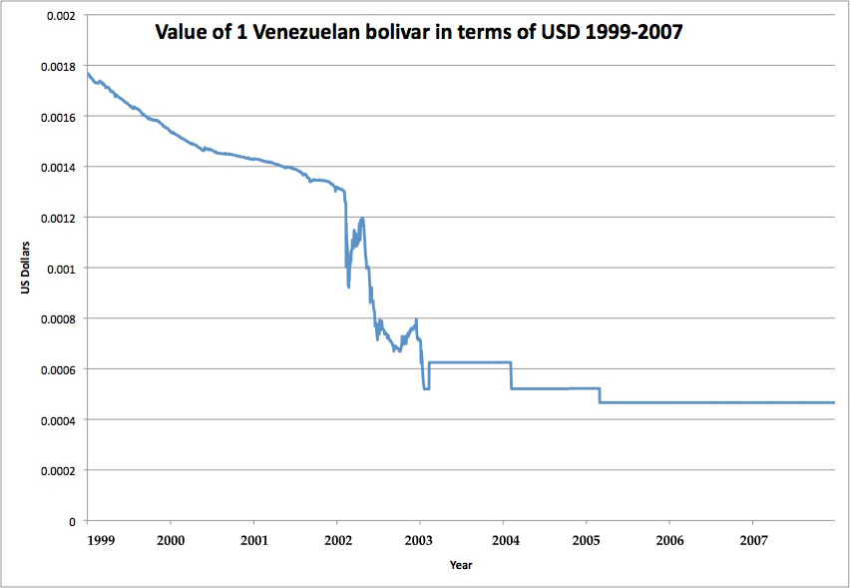Figure 11*: *Exchange Rate of Venezuelan Bolivars to US Dollars*[34]

While recurrent devaluation of the currency is meant to encourage growth and development of the domestic economy by making imports more expensive, there are several problems that can quickly arise. For example, inflation, which is already at 27%, could worsen by as much as 5 percentage points, according to Venezuelan Finance Minister Ali Rodriguez.[35] Furthermore, there is no guarantee that a currency devaluation will yield a more vibrant domestic economy, especially because the essentials exchange rate is valued at 2.6 *bolivars fuerte* to 1 USD, making it relatively cheap for Venezuelans to continue to import essential goods rather than producing them domestically. While the reasoning behind this dual exchange rate is to promote the domestic production of non-essential goods, it does nothing to help domestic producers of essential goods. A lack of domestic production of essentials may prove to be a risky move in the long run.

### **Composition of Exports and Imports**

The nature of a country’s exports and imports can be extremely useful in understanding its two gap. In the case of Venezuela, it is important to note, as shown in Table 12, that oil exports account for a tremendous percentage of Venezuela’s exports, and consequently, that non-oil imports account for an equally high percentage of its imports. These percentages are reflected in Figure 12, and they show that the composition of both exports and imports has remained fairly stable for the period 1997 to 2009. This indicates that President Chavez has continued to focus his attention on the strength of the petroleum sector. However, it is also important to note that Venezuela’s dependence on oil places it in a position of subordinance to the oil market, a market which has experienced periods of extreme volatility in the past. Therefore, a possible course of action for the future may be to seek to reduce Venezuela’s dependence on oil exports and non-oil imports by building the relative strength of other sectors of the economy.

*Table 12: Composition of Exports and Imports (in millions of USD), 1997-2009*[36]

|  |  |  |  |  |  |  |  |
| --- | --- | --- | --- | --- | --- | --- | --- |
|  | *1997* | *1999* | *2001* | *2003* | *2005* | *2007* | *2009* |
| Exports | 23,871 | 20,963 | 26,667 | 27,230 | 55,716 | 69,010 | 57,595 |
| Oil Exports | 18,330 | 16,735 | 21,745 | 22,029 | 48,143 | 62,640 | 54,201 |
| Non-Oil Exports | 5,541 | 4,228 | 4,922 | 5,201 | 7,573 | 6,370 | 3,394 |
| Imports | (14,917) | (14,492) | (19,211) | (10,483) | (24,008) | (46,031) | (38,442) |
| Oil Imports | (1,256) | (1,446) | (1,781) | (1,342) | (2,409) | (4,414) | (3,970) |
| Non-Oil Imports | (13,661) | (13,046) | (17,430) | (9,141) | (21,599) | (41,617) | (34,472) |

*Figure 12: Composition of Exports and Imports, 1997-2009*

### **Trade Balance**

Figure 13 illustrates Venezuela’s trade balance for the period 1997 to 2009. The figure includes average annual oil prices, which are mapped against the right vertical axis. Over this time period, Venezuela has consistently enjoyed a trade surplus in the range of billions of US dollars. Venezuela’s petroleum exports account for nearly the entire volume of its trade surplus. In 2009 for example, petroleum accounted for 94% of Venezuela’s exports. There is also a strong and evident correlation between crude oil prices, export levels, and the trade balance. Venezuela’s reliance on oil is risky and unsustainable in the long term. Without oil, Venezuela would most likely generate massive trade deficits, especially given its dependence on imports. Furthermore, a heavy reliance on oil puts Venezuela at the mercy of both the dollar as well as the international economy. As is evident in the massive swings in export totals in 2007, 2008, and 2009, Venezuela can neither control nor predict the profits that oil exports will generate. This makes economic policy and planning difficult in the short term. In the long term, Venezuela’s current economic paradigm with regard to trade is not feasible. Oil is a nonrenewable resource, and while Venezuela’s reserves are vast (between 50 and 150 years remaining, depending on method of projection), they are also finite. It will be difficult for Venezuela to maintain a trade surplus into the future as the inevitable transition away from oil and towards other sources of energy begins to occur.

*Figure 13: Exports, Imports, Oil Prices, and the Trade Balance, 1997-2009[37]*

### **Debt**

The debt level of a given country can be extremely helpful in understanding its two gap. Figure 14 provides the present values of debt as a percentage of GNI for various Latin American countries. [38] It is important to note that Venezuela’s present value of debt as a percentage of GNI is 48.2%; this percentage reflects the approximate median of the data shown in Figure 14. This level of debt indicates that Venezuela is performing relatively well in comparison to other Latin American countries, and while this debt is not an urgent issue, it must be addressed in the future.

*Figure 14: Present Value of Debt as % of GNI, 2005*[39]

In addition to examining the present level of debt as a percentage of GNI, it is valuable to analyze the growth of that debt. Figure 15 shows Venezuela’s external debt, both short term and long term, for the period 1997 to 2008. Total external debt has generally increased from 2002 onward, a trend that reflects the massive levels of public spending on social programs initiated by the Chavez administration under the banner of “21st Century Socialism.”

*Figure 15: External Debt, 1997-2008*[40]

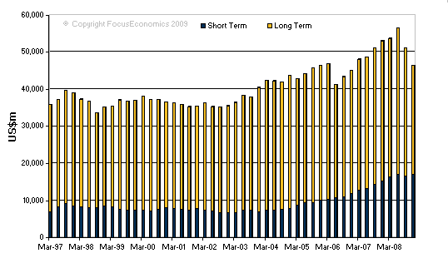

Analysis of the Venezuelan two gap can provide important information regarding its future development potential. Venezuela’s two gap is not a hurdle to development, as Venezuela’s plentiful oil-derived foreign exchange allows the nation to import as it pleases.

## Three Gap

Over the period 2000 to 2007, *[41]* Venezuela went from running a modest budget deficit of $5.5 billion to running a budget surplus of $6.93 billion, as shown in Figure 16.[42] According to 2009 estimates, however, Venezuela was running a sizeable budget deficit of $26.9 billion.[43] This trend underscores the vast increases in government spending that have occurred in the past several years, of which spending on social programs is an element of particular focus for the Chavez administration. Indeed, 45.73% of the proposed national budget for 2010 will be “directed towards social spending aimed at poverty reduction and improving the quality of life for Venezuelans” according to Alí Rodríguez Araque, the Venezuelan Minister for Finances and the Economy.[44] In addition to social spending, the national budget will also focus on five strategic objectives in order to spur growth: increase food production and move towards food sovereignty; address the housing shortage; develop and improve infrastructure; boost energy production and distribution; realign the domestic financial sector to promote productive sectors.[45] Thus, it is clear that Venezuela’s budget expenditures are directed toward both social programs as well as future growth. In terms of budget revenues, Minister Rodríguez stated that tax revenues would finance 53% of the budget, oil revenues 24.7%, and the incursion of foreign debt the remainder.[46]

Public debt is both manageable and sustainable in Venezuela. Trends in the national budget demonstrate the relatively small need for Venezuela to borrow. According to the CIA World Factbook, Venezuela’s debt was only 13.8% of GDP in 2008, and 19.4% of GDP in 2009. While this rise in debt from 2008 to 2009 is slightly unsettling, the numbers still fall well within the range regarded to be acceptable.

Thus, we can conclude that Venezuela is willing to allocate its resources in such a way as to achieve objectives of both growth and development. We further postulate that the national government will be relatively receptive to the policy proposals we have formulated. Two such proposals are discussed in the sections that follow.

*Figure 16: Venezuelan National Budget, 2000-2007*

## Secondary Education

One source of potential development in Venezuela is in the area of secondary education. Venezuela’s recent performance in terms of education in general demonstrates that although significant progress has been made in the areas of literacy and primary education, the same cannot be said of secondary education. In addition, the unequal distribution of resources to education reflects this bias toward the lower levels of the Venezuelan educational system.

Several development theorists have made important contributions in terms of illustrating the benefits to be derived from a focus on education. Anand and Sen assert that “a general increase in educational levels, for example, will raise productivity and the ability to generate higher incomes, now and in the future.”[47] Other theorists have conducted a more focused analysis of the consequences of secondary education in particular. Hadden and London conclude that the provision of secondary education, and more especially the provision of secondary education for girls, can have substantially positive effects in less developed countries.[48] Indeed, their research shows that secondary school enrollment and attendance have a noticeable effect on the overall reduction of fertility as well as both infant and childhood mortality. Furthermore, these effects are greater than those of primary school enrollment and attendance. Thus, while a strong foundation in primary education is essential for stimulating initial development, strength in secondary education is crucial for continuing that development.

In the section that addresses recent trends in Venezuela in terms of education, we took note of various trends in primary and secondary school enrollment rates, as well as of public expenditure patterns with regards to the various levels of the educational system. Thus, a brief reiteration of our findings will suffice to illustrate the significance of focusing future resources on secondary education. While secondary school enrollment rates increased from 47% to 68% over the period 1999 to 2007, these rates remain below those of primary school enrollment. Furthermore, public expenditure on secondary education is approximately half of public expenditure on primary education, 17% and 32% respectively. The percentage of the labor force with a secondary education is also approximately half of the percentage of the labor force with a primary education, 30% and 61.9% respectively. In comparison to other Latin American countries, we concluded that Venezuela’s performance could be deemed appropriate. This, however, does not signify that the status quo is adequate and should remain unchanged.

In order to transform secondary education from an obstacle hindering development to a source of development, we believe that a reconfiguration of the way in which public expenditure is directed toward the various levels of the educational system is necessary. More specifically, we regard it as essential that the Venezuelan national government shifts its focus from primary education to secondary education. Hence, we regard the Venezuelan state as a future partner in this approach to development.

# Constraints

Multiple actors and forces exist in Venezuela which could act as constraints on the adoption or success of a development policy. These must be given adequate consideration in order to arrive at a policy which is likely to be accepted and successful given the political and economic climate of Venezuela. Even if a policy is accepted, it could still face challenges during the execution phase in terms of financing and the manner in which it is implemented.

An initial first obstacle to be aware of when attempting to make recommendations to Venezuela on development is the government of Venezuela itself. The adoption of a given policy could face severe disapproval based on President Chavez’s ideological reasons alone. As an opponent of the Western standards of requisites of economic development, such as capitalism and free trade, President Chavez has chosen to approach the topic of development in an entirely different way. President Chavez’s 2007 political campaign attacking globalization and existing democratic institutions demonstrates his alternative perspective on the forces that spur growth and development. Instead, he campaigned with a “21st Century Socialism” platform, making it a major goal of the state to alleviate social problems. A key policy of President Chavez’s is nationalization of key industries. In 2007 and 2008, Venezuela took nationalization even further by taking the cement industry and the steel industry into state hands, as well as nationalizing the last remaining oil sites which were under foreign control.[49] By nationalizing key firms President Chavez displays his confidence in the state over the private sector in being more efficient and bringing about economic growth and development.

This sort of approach to development tremendously limits the scope of possible development policies. Any slightly Western recommendations would be immediately rejected and thus it is futile to even consider them as an option, even if we personally deem them the best choice. The government of Venezuela will thus be the major limiting factor in the adoption of certain development policies.

Even if our policy recommendations are accepted and adopted, however, there are still potential downfalls while they are being implemented. Although currently financing such policy changes is feasible as indicated by the budget surplus, we cannot ignore the fact that the budget surplus is largely due to the unprecedented soaring world oil prices. Venezuela’s oil accounts for 90% of revenues from all exports, over 50% of the government budget, and roughly 30% of the GDP. An economy so heavily reliant on a natural resource can be dangerous. While during times of high oil prices the domestic economy is positively affected with a huge increase in revenues, worse times for oil prices have a strong negative implication on revenues. Any disruption in the world oil market would tremendously impact Venezuela’s ability to follow through with specific policies. There are a number of factors that could potentially influence revenues earned from oil exports. These include a drop in the world price of oil, a natural disaster that would reduce oil production, problems with aging petroleum infrastructure, and other geopolitical issues. Notably, the United States is one of Venezuela’s most important trading partners and tense relations between the two governments, such as those that existed during George W. Bush’s presidency, could undermine this economic relationship. Since oil revenues are the primary source of funding the national budget, any of these disturbances could severely limit Venezuela’s freedom of action to continue with an adopted development policy.

Yet another potential major barrier to successfully implementing a development policy is the weak governance indicators of Venezuela. Mainly, corruption is a primary constraint on a policy being effectively implemented. However, other important factors include rule of law and government effectiveness. According to sources such as Transparency International, the World Bank, and Freedom House, these indicators have fallen drastically during President Chavez’s time. This is ironic, as President Chavez first came into power in 1998 promoting a crackdown on corruption. In fact, over the past ten years, corruption has worsened dramatically, with the latest data from 2009 ranking Venezuela at 162nd out of 180 countries. Such a high level of corruption is a dangerous trend as it can be detrimental to economic development. Table 13 depicts Venezuela’s transition over President Chavez’s time according to Transparency International, which ranks every country on the Corruption Perception Index according to individual countries’ perceptions of their domestic levels of corruption relative to other countries.

*Table 13: Transparency International Corruption Ranking*

|  |  |  |  |  |  |  |  |  |  |  |  |
| --- | --- | --- | --- | --- | --- | --- | --- | --- | --- | --- | --- |
| **Year** | 1999 | 2000 | 2001 | 2002 | 2003 | 2004 | 2005 | 2006 | 2007 | 2008 | 2009 |
| **Rank** | 77 | 75 | 69 | 81 | 100 | 114 | 130 | 138 | 162 | 158 | 162 |

Corrupt public officials looking out for their own interests would limit the scope of success of development policies. In addition, with a widening role of the state in the economy, opportunities for corruption are becoming more and more widespread, as more individuals are being placed in positions of public power which they could easily abuse for private gains. The selective enforcement of good government laws and regulations that President Chavez’s government practices is extremely biased as it only hurts any opposing groups and neglects to punish others.[50]

It is clear that corruption exists and has become significantly worse in Venezuela over the last decade. There are several reasons as to how corruption can have a negative impact on growth and development. For example, public officials receiving private gains have little incentives to work towards development for the rest of the population. In addition, corruption can bring about the diversion of funds from an efficient use to a less efficient use. Corruption may mean that the most qualified lose while those that have the ability to partake in the corrupt activities benefit. Ultimately, corruption can imply a loss of confidence in the government by the public. The effects of corruption on the economy can be extremely unfavorable, and it is crucial to consider any potential policy recommendation in the context of corruption and see what kind of implications that will have.

In addition to corruption, rule of law is an important governance indicator which can play a constraining role to certain development policies. The rule of law is based on individuals’ perception of the government’s creation and fair enforcement of law. Venezuela has experienced a drastic drop in the rule of law category over the past few years. Table 14 displays Venezuela’s falling rule of law percentile ranking relative to other countries.

*Table 14: World Bank’s Rule of Law Ranking*

|  |  |  |  |  |  |  |  |
| --- | --- | --- | --- | --- | --- | --- | --- |
| **Year** | 1996 | 1998 | 2000 | 2002 | 2004 | 2006 | 2008 |
| **Percentile Rank** | 30 | 25.7 | 27.6 | 14.3 | 9.5 | 4.8 | 2.9 |

Venezuelans’ perception that their government is partial in the enforcement of law is harmful to society as it further lowers people’s confidence in the government. According to Freedom House, Chavez supporters fill the positions of the Supreme Court as well as lower courts throughout the country. This has a detrimental effect as it breeds more corruption. Public officials are hardly ever prosecuted for abuse of public power. The perception of an unfair judicial system in the country can severely stifle development as it may make individuals risk-averse if they fear they have no protection from the government.

Yet another indicator of governance is government effectiveness. In this category Venezuela has shown a consistent drop throughout the last decade. Table 15 traces Venezuela’s descent.

*Table 15: World Bank’s Government Effectiveness Ranking*

|  |  |  |  |  |  |  |  |  |  |  |
| --- | --- | --- | --- | --- | --- | --- | --- | --- | --- | --- |
| **Year** | 1996 | 1998 | 2000 | 2002 | 2003 | 2004 | 2005 | 2006 | 2007 | 2008 |
| **Percentile**  **Rank** | 19.4 | 36 | 26.1 | 15.6 | 18 | 16.6 | 22.7 | 22.7 | 17.5 | 17.1 |

A falling ranking of government effectiveness most likely implies, in Venezuela’s case, deterioration in the effectiveness of bureaucracy, more red tape, and extra unnecessary regulations, among other such characteristics. Lower government effectiveness has a negative effect on development as it can add needless delays to the process and can make it much more difficult for plans and policies to actually be carried out.

There are many constraints facing us in developing a realistic policy proposal for Venezuela, mainly the ideology of President Chavez, oil dependence, and the rampant corruption levels in the country among other poor performing governance indicators. These are obstacles we have considered and are trying to overcome in order to produce recommendations we think will be adopted as well as implemented successfully.

# Policy Proposals

## Investment in Secondary Education

The first policy change we propose is increased investment in secondary education. Recent trends in secondary school enrollment rates demonstrate the relative necessity of emphasizing this level of the educational system. We suggest that, in light of the fact that the national government already devotes a great deal of its resources to social programs, a renewed focus on secondary education in particular will reflect President Chavez’s vision of “21st Century Socialism.” In addition, we strongly believe that seeking to overcome this obstacle to development will yield positive results, the most notable being a widespread increase in the country’s supply of human capital. Such an increase will in turn enhance Venezuela’s ability to achieve other developmental objectives.

## Control of Corruption

The next policy change we propose would aim to decrease the rampant corruption which acts as an obstruction to development. Since corruption diverts the efficient use of funds for other less efficient uses, Venezuela’s deteriorating position in terms of corruption over the past decade has most likely slowed down Venezuela’s development and had corruption been nonexistent, we would expect to see Venezuela more developed than it actually is today. Strong anti-corruption policies would need to be enacted as well as enforced in a fair manner in order to have a chance at successfully combating corruption. A less corrupt government would be more likely to look out for the interests of the general population rather than its own interests. Reducing corruption would thus enable development to further thrive.

## Investment In Oil

A last possible policy proposal revolves around the oil sector. Current policy diverts significant sums of oil revenue to non-oil projects. While this provides short-term benefits to the nation, it leaves the oil sector in danger of falling into obsolescence. Thus, we propose a renewed focus on oil infrastructure, especially in the Orinoco Belt region. The oil in this region is more difficult to extract, and will require a significant investment. Venezuela must make this investment, as large portions of its proven reserves exist there.

1. Council on Foreign Relations “Venezuela’s Oil-Based Economy” http://www.cfr.org/publication/12089/
2. All oil statistics come from OPEC’s 2008 Annual Statistical Bulletin
3. This equates to increasing production by about 3.5% per year.
4. Council on Foreign Relations “Venezuela’s Oil-Based Economy” http://www.cfr.org/publication/12089/.
5. Foreign Affairs. “A Benign Revolution”. http://www.foreignaffairs.com/articles/61747/bernardo-alvarez-herrera/a-benign-revolution
6. Center for Economic and Policy Research “The Venezuelan Economy in the Chavez Years”. http://www.cepr.net/documents/publications/venezuela_update_2008_02.pdf
7. Council on Foreign Relations “Venezuela’s Oil-Based Economy” http://www.cfr.org/publication/12089/
8. Ibid.
9. “ERS/USDA Data – International Macroeconomic Data Set” USDA Economic Research Service. http://www.ers.usda.gov/Data/Macroeconomics/
10. http://www.nytimes.com/2002/04/14/world/a-chavez-comeback-more-astounding-than-his-fall.html?pagewanted=all AND http://www.sfgate.com/cgi-bin/article.cgi?file=/chronicle/archive/2002/12/07/MN128972.DTL
11. OPEC Annual Statistical Bulletin. http://www.opec.org/library/Annual%20Statistical%20Bulletin/interactive/2008/FileZ/Main.htm
12. World Bank’s World Development Indicators Database
13. CIA World Factbook: https://www.cia.gov/library/publications/the-world-factbook/rankorder/2172 rank.html
14. World Bank’s World Development Indicators Database
15. “Statistics, U. I. (2009)”. *UNESCO Institute for Statistics: UIS Statistics in Brief: Education in Venezuela*.. tinyurl.com/ye5tpb4
16. “Statistics, U. I. (2009)”. *UNESCO Institute for Statistics: UIS Statistics in Brief: Education in Venezuela*.. tinyurl.com/ye5tpb4
17. GER is the number of students enrolled in a given level of education, regardless of age, expressed as a percentage of the population in the theoretical age group for that level of education. Because this number involves the total number of students in a given grade, a higher number may, in fact, reflect poorly on the education system, as it implies students are not successfully advancing when they should be. If a country, for example, has 100 students eligible for grade 6 based on age, but has 120 students enrolled in grade 6, their GER would be 120. This means that roughly 20 students should be enrolled in a higher grade. NER is the number of students in the theoretical age group who are enrolled expressed as a percentage of the same population. GER numbers can be misleading, so we will focus on NER.
18. “Statistics, U. I. (2009)”. *UNESCO Institute for Statistics: UIS Statistics in Brief: Education in Venezuela*. 2/7/10. tinyurl.com/ye5tpb4
19. “Statistics, U. I. (2009)”. *UNESCO Institute for Statistics: UIS Statistics in Brief: Education in Venezuela*. 2/7/10. tinyurl.com/ye5tpb4
20. “Statistics, U. I. (2009)”. *UNESCO Institute for Statistics: UIS Statistics in Brief: Education in Venezuela*. 2/7/10. tinyurl.com/ye5tpb4
21. “Statistics, U. I. (2009)”. *UNESCO Institute for Statistics: UIS Statistics in Brief: Education in Venezuela*. 2/7/10. tinyurl.com/ye5tpb4
22. “Statistics, U. I. (2009)”. *UNESCO Institute for Statistics: UIS Statistics in Brief: Education in Venezuela*. 2/7/10. tinyurl.com/ye5tpb4
23. In this system, ISCED 1 refers to primary education, ISCED 2 to lower secondary education, ISCED 3 to upper secondary education, ISCED 4 to post-secondary non-tertiary education, ISCED 5 to the first stage of tertiary education, and ISCED 6 to the second stage of tertiary education.
24. “Statistics, U. I. (2009)”. *UNESCO Institute for Statistics: UIS Statistics in Brief: Education in Venezuela*. tinyurl.com/ye5tpb4
25. http://stats.uis.unesco.org/unesco/TableViewer/document.aspx?ReportId=125&IF_Language=eng&BR_ Fact=EEGDP&BR_Region=40520
26. “WHO Statistical Information System”.  *World Health Organization.*
27. “WHO Statistical Information System”.  *World Health Organization.* 
28. “WHO Statistical Information System”.  *World Health Organization.*
29. “The World’s Water 2008-2009”. *Pacific Institute: Information on the World’s Fresh Water Resources.* 
30. “The World’s Water 2008-2009”. *Pacific Institute: Information on the World’s Fresh Water Resources.* 
31. The World’s Water 2008-2009”. *Pacific Institute: Information on the World’s Fresh Water Resources.*
32. “The World’s Water 2008-2009”. *Pacific Institute: Information on the World’s Fresh Water Resources.*
33. All statistics are from WDI.
34. Federal Reserve Bank of New York.
35. “Chavez Devalues Venezuela’s Currency.” The Wall Street Journal. January 9, 2010.
36. Banco Central de Venezuela
37. Banco Central de Venezuela
38. The present value of debt is the sum of short-term external debt plus the discounted sum of total debt service payments due on public, publicly guaranteed, and private nonguaranteed long-term external debt over the life of existing loans. The GNI denominator is a three-year average.
39. http://www.nationmaster.com/graph/eco_pre_val_of_deb_of_gni-economy-present-value-debt-gni&date=2005
40. http://www.latin-focus.com/latinfocus/countries/venezuela/vendebt.htm
41. All budgetary figures are recorded in billions of US dollars.
42. http://www.nationmaster.com/cat/Economy-economy
43. CIA World Factbook
44. http://venezuelanalysis.com/news/4881
45. http://venezuelanalysis.com/news/4881
46. http://venezuelanalysis.com/news/4881
47. Anand and Sen. “Human Development and Economic Sustainability.” 2000
48. Hadden and London. “Educating Girls in the Third World.” 1996
49. “Venezuela’s new nationalization drive.” Reuters. 9 April 2008.
50. Freedom House.